Phase 1 – Project Plan

Vacation Planner

# Blond Squad

Engelbrecht, T u22633601

Ortner, JA u21463230

Park, TM u22556908

Jacobs, J u21674605

Email address for feedback: u22633601@tuks.co.za

|  |  |  |  |  |
| --- | --- | --- | --- | --- |
| Needs Identification [10] | User Identification  [20] | User needs  [10] | Conceptual Design  [10] | Total  [50] |
|  |  |  |  |  |

## Question 2 - Needs identification:

The intention of a travel application is to allow users to plan a trip in the most efficient way such that their specific travel goals are fully satisfied. In this space the general need is for the user to plan a trip that suites them. But these users have different intentions when they commence on such a trip such as business trips, holidays, sightseeing, etc. The ultimate goal of such an application is to create a platform in which users are capable of planning an efficient trip that corresponds with their trip intentions.

### The potential problem space of such an application could be as follows:

Budgeting:

* Short comings:

Majority of users have a limited budget and the ones who do not are unlikely to have the need for such an application. Often these budgets aren’t maintained due to users having to consult numerous platforms to create their various bookings and query pricing.

* Possible Solutions:

A budget planner could be beneficial such that the application could integrate various booking/pricing features into a single application, such as integrating flight plans, including restaurant menus, showing different accommodations, including the prices of attractions, incorporating exchange rates, etc.

* Reasons for lack of implementation:

App developers often fall short on accounting for the user budget since they expect the user to work out their own finances. Most applications aren’t developed to account for overall budget for the trip, they specialize in one thing then leave the rest up to the users. Users are left without having a full overview of the cost of the trip because they are required to consult numerous platforms, creating an overall tedious process.

##### Accounting for the purpose of the trip:

* Short comings:

Students, business travellers and families have very different needs in terms of the type of accommodation and environment where they want to stay in.

* Possible solutions:

A filtering system could possibly be added such that these needs are considered. Possible filtering examples could include relaxing getaway, family friendly resort, areas with active nightlife, art and architecture, culinary experiences, just to name a few.

* Reasons for lack of Implementation:

Applications often don’t offer any sort of filtering for the type of trip envisioned, creating a gap where users may make bookings to regions that won’t satisfy their need for the trip. Developers don’t examine the type of environment and mainly just focus on availability and cost instead of delving further into the specific needs of the client.

##### Mode of travel:

* Short comings:

The mode of travel can go hand in hand with the budget scheme since many travellers aren’t aware what the most efficient transport mode may be. This includes both considering the mode for arriving to the destination as well as transportation within the region.

* Possible solutions:
  + - Does it make more sense to fly to the destination or travel via car?
    - When you arrive are there Ubers available?
    - Are their accommodations for parking a rental car?
    - Does it make more sense to take public transport?

These are all vital points that should be answered and communicated to the user when looking at a specific region so that they can make an informed decision of how they’re going to get about.

* Reason for lack of Implementation:

Once again developers are often focused on single aspect when it comes to these applications and the trip is not designed as a whole. If transportation options are considered, they are often very limited. This leaves users with no opportunity to make comparisons between different transportation options.

##### Seasonal advisories:

* Short comings:

Weather and peak tourist seasons will have influence on the cost and how enjoyable the holiday season may be. Majority of platforms simply take in the dates without providing users with suggestions or even vital information of the best timeframes that also satisfy the users budget and availability.

* Possible solutions:

Suggestions can be made to the users to advise them on the best window for them to travel. This includes advising on prices on flights, which can fluctuate substantially, even within the course of a week.

* Reasons for lack of Implementation:

This may be because developers just advertise and aren’t aware of the need to take one step further for those traveling to foreign regions who are unaware that there may be more convenient times in which they can travel.

##### Legal advisories:

* Short comings:

Users are often left to do their own research through different means to find out what is needed for them to be able to legally travel to their desired destination. Travel application may just give a basic outline of what is require but leave the rest up to the individual, this can leave room for error since different countries have different legislations. Integrating such a feature into the system could possibly eliminate such potential.

* Possible solutions:

The application could give pointers on Visas and necessary documentations one may need to travel to different region. There is even potential to employ AI chat boxes or live assistants that users can consult for guidance on how to gather all the correct documentations.

* Reasons for lack of Implementation:

Programmers may not be employing this feature because they may want to avoid liability for information that may be incomplete or outdated. They could also possible not have access to the resources to perform such a task.

##### Safety:

* Short comings:

Some countries have areas with high crime rates where it is not recommended for foreigners to visit. If users do not do prior research and are unaware of these areas it may potentially put their lives at risk.

* Possible Solutions:

A safety feature could be added such that high crime areas aren’t included or are at least disclosed to user. This could include both safe accommodation as well as safe routes for clients travelling through the region.

* Reasons for lack of Implementation:

Safety aspects are often absent because app developers may not even be aware of such a need or might not have enough in-depth knowledge of the region to provide this information.

##### Overwhelming design:

* Short comings:

Majority of available platforms are overbearing and tend to leave the user overwhelmed with how much planning is required before going on such an expedition.

* Possible Solutions:

A simplistic design with an easy to follow, step-by-step system or booking agenda can make a world of a difference. This guided scheme could bring comfort to the user since they’re capable of covering all their bases within one application all in a sequential manner.

* Reasons for lack of Implementation:

Developers tend to lean one of two ways, either the platform is far too confusing and overloaded with content creating a daunting experience or completely sparse leaving the user to once again consult other sources to complete their agenda. This may be due to client specifications who may want focus on a singular aspect of travel or who have too many needs to fulfil creating more confusion than benefit.

## Question 3 - User identification:

Our general user base refers to individuals and groups, such as families or friends who long for personalized travel experiences. Primarily, these users are those people who plan their trips for leisure, exploration, and relaxation. We aim to serve a wide range of users with our vacation planning app, including families, single travellers, business travellers, and regular travellers. For regular travellers, we provide easy-to-use trip planning and tailored suggestions. Real-time information and simplified trip planning are advantageous for business travellers. Features like group itinerary sharing and kid-friendly activities are appealing to families. Travelers who go alone meet people and choose places that are conducive to traveling alone. Adventurers can find heart-pounding adventures, and those on a tight budget can find reasonably priced choices. Retirees like senior-friendly lodging, and luxury tourists value personalized recommendations. Honeymooners and couples can organize romantic trips without too much hassle. Reliable Wi-Fi and co-working spaces are accessible to digital nomads. The goal of our app is to make this process of planning a vacation that much easier by providing an easy-to-understand interface that contains a place where you can efficiently plan your itinerary and provide you with accurate recommendations for an unforgettable vacation. We aim to make our app accessible for users all around the world and adaptable for all sorts of travelling from planning a trip for leisure or adventure. By customizing our software for various markets, we make everyone's travel experiences better!

### The above-mentioned general user base can be further specified into three groups, such as tourists, family travellers and budget-friendly travellers.

##### Tourists:

* This user group includes all the travellers who like to visit new places for sightseeing, unique cultural experiences, and adventures. They can be either tourists from abroad or within the country.
* Tourists can use the app to make comprehensive itineraries that include places to see, things to do, and places to dine.
* They can use the app to plan a day to explore landmarks, museums, historical sites, and all other sightseeing needs.
* Tourists will rely on the app for the navigation of maps, directions, as well as real-time location tracking.
* Tourists are looking for individualized suggestions based on previous experiences, as well as for local experiences, and must-see places.
* Tourists can use the app for local event suggestions to be able to participate in the local culture activities.
* These users are also more likely to make use of the app’s feature of translating their thoughts to the local spoken language to overcome any possible language barriers. They can also make use of in-app tips on how to interact with the local people that can provide a more authentic experience.

##### Family Travelers:

* This user group refers to travelling families consisting of parents and their children. It can also include other relatives, for example grandparents or cousins.
* Family vacationers will use the app to choose locations, family-friendly activities, and accommodations.
* They will also be more likely to search for amusement parks, zoos, and other kid-friendly attractions.
* Parents will most likely depend on the app to provide emergency contacts and medical information near their accommodation for easy access in case an emergency arises. They can even make use of an in-app family locator for easy tracking of their little ones.
* Another feature that is sure to be used by this user group is the checklist feature that can help the parents check if their children have all their essential items packed.

##### Budget-conscious travellers:

* Budget-conscious travellers refer to travellers on a tight budget looking for low-cost options without sacrificing once-in-a-lifetime experiences. This includes students and young adults who may be au pairing overseas in a country they have never been before and want to explore while having the opportunity to do so.
* This user group may use the app for locating inexpensive accommodation, low-cost flights, and free or discounted activities through the help of a filter on the app.
* These travellers will also be using the app’s feature for real-time budget management which will help them track all their expenses and enable them to see how much they still have left to spend and help them stay within their budget limits.
* They will also use the app to locate reasonably priced restaurants and cafes.

## Question 4: User Needs

#### Product Needs for General user base:

Integrated Budget Planner :

* The app needs to have a budget planner that calculates all of the costs associated with travelling, such as:
  + Accommodation
  + Meals
  + Attractions
  + Flights
  + Transportation around the area

##### Trip Purpose Filtering System :

* A filtering system can be implemented that takes into account the different needs of travellers, allowing them to plan their trip based on specific purposes such as:
* Business
* Family
* Leisure

##### Mode of Travel Information :

* Users should be provided with detailed information on the different modes of travel, for both getting to the destination and transportation around the area.
* This includes information on:
* Flights
* Car rentals
* Public transport

Seasonal and Legal Advisories :

* Provide users with seasonal advisories to

help them decide when it will be best to travel based on the weather and the

busiest travel seasons. Include legal advice as well, such as information on

visa requirements and regionally specific documentation requirements.

Safety Advisory and Filtering :

* A safety tool should be implemented that

provides users with information on the safety of accommodations, routes, and

areas, with the option to filter out high-crime areas.

#### Specific User Needs:

##### Tourists:

* Personalised Itinerary Planning: A tool that helps travellers with creating

customised itineraries by recommending destinations, things to do, and

restaurant options based on their interests and past experiences.

* Navigation and Location Tracking: A map tool with real-time navigation

features with map integration and location tracking should be included to help

tourists with navigating unfamiliar areas.

##### Family Travellers:

* Family-Friendly Activities and Accommodation: A filter should be included to

filter through family-friendly activities and accommodations, assisting family

travellers in finding destinations and activities suitable for the whole family.

* Emergency Contacts and Medical Information: Include a tool that provides

quick access to emergency contacts and medical information near the

accommodation and activity destinations, to help parents have quick access

to emergency services.

##### Budget-conscious travellers:

* Expense Tracking and Budget Management: Include an expense tracking and

budget management tool, helping budget-conscious travellers monitor their

expenses and not go over their personal budget. They can also use this to

help them budget their expenses ahead of time.

* Discounted Accommodation, Activity and Dining Filters: Filters for locating

discounted accommodation or discounted/free activities and reasonably

priced restaurant options should be included, helping budget-conscious

travellers in maximising their experiences without having to spend over their

budget.

### Question 5: Conceptual Design

##### Budget-conscious traveler:

As a budget-conscious traveler using a vacation planning application, I envision a straightforward and user-friendly experience. Upon opening the app, I'd appreciate a brief introduction explaining its purpose and features. Next, I'd set my travel budget upfront, including flights, accommodation, food, and activities. When searching for destinations, the app should display options within my budget. Once I choose a destination, an itinerary builder would be helpful, suggesting daily activities (including free or low-cost options) that I can customize. Throughout the planning process, I'd like a clear breakdown of costs (accommodation, transportation, meals). Lastly, provide local tips—hidden gems, affordable eateries, and public transport hacks—without unnecessary luxury recommendations. Simplicity, cost awareness, and practicality are my priorities! ~ Courtenay Botha 0795008677

##### Bad Design Concepts:

* In the first image, if people input their budget once they may find it difficult to change the budget at different destinations. As a solution we might want people to input a budget for different components, like travel, food, and activities in different places.
* In the last two images if users only input a budget, they might have a hard time finding activities or travel plans inside their budget if it is not realistic. This limits people who only want to see some cheaper options if they don’t have a set budget yet but are trying to plan a realistic budget. We might want to filter according to their budget and suggest a bigger budget if it is not realistic or if there are too few options.

##### Inspiration from AI Images:

* In the first image: I like the layout and bubbles in the firs image, all the information is very clear and not too overwhelming. The budget is very clear and always gives people an idea of their finances.
* The first image also gives the weather at that place in the background letting people know what to expect. This is a good idea and could users pick a good time to visit the destination and know what to pack.

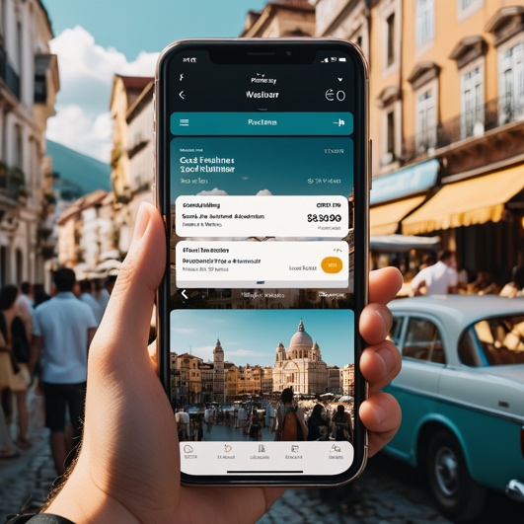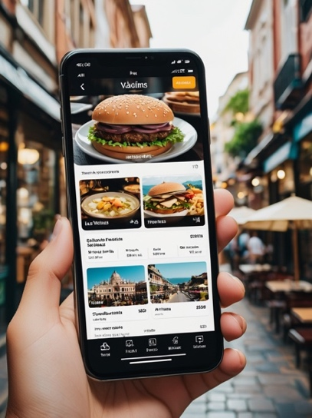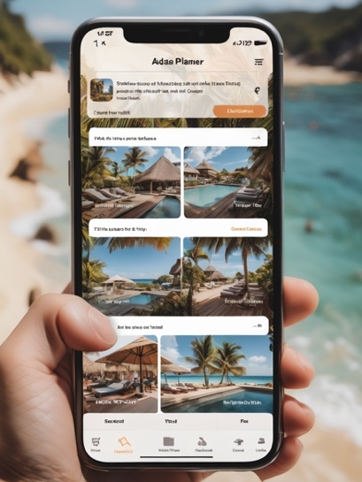

##### Tourist:

For me the biggest thing about any app is that it should be very user friendly because I suck with technology!! I would love to see clear options on locations to visit followed by options on how to get there (transport etc.) and then maybe a list of activities to participate in while I am there. The flow must be in order and easy to follow. Prices must be included in every step. Pictures of accommodation and activities is a must! I would not want to read long paragraphs of descriptions but rather quick summaries or bullet points. I would like to see my preferences at the top, along with special deals and top places to travel. Along with that to be able to select destinations, categorize them and edit pre-planned trips to fit my need. I wouldn't want to see adds while browsing the app or destinations that are not to my liking. It should flow easily from choosing a destination to having a choice between creating our agenda for your trip from scratch or merely editing a pre-scheduled trip to fit to my liking. It should be easy to use and effective, straight to the point (keeping the main purpose of the app in mind).~ Leandri Erasmus 0646848694

##### Bad Design Concepts:

* Having so many different options open on the page might become confusing or overwhelming to some users. Like in the firs picture, there is too much text options to read for users. We could maybe group some of the options together and only display it if clicked or hover over. We could also use descriptive icons instead of text.
* In the last image, the images are too big and could become irritating to users if they must scroll down a lot to see more content, there is also not enough text and information displayed for the locations. We could make the images smaller to fit more on the page and have text displayed over the images to give more information.

##### Inspiration from AI Images:

* I like the carousel of images in the second picture, it is easy to view and works well on a mobile view. I like the choose button and the share button with clear instructions and easy to navigate design.
* I also like the size of the images in the first image, it is big enough to see the entire image, but still fits more than one image on a page.

